25.6: The atomic weight of copper is 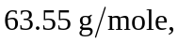and its density is 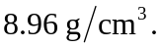 The number of copper atoms in 
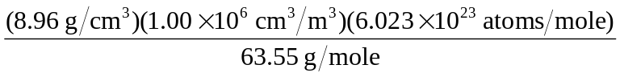
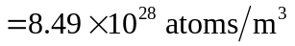
Since there are the same number of free 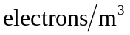 as there are atoms of 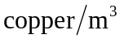 (see Ex. 25.1), The number of free electrons per copper atom is one.

